
NAME: MICHAEL SETH KWAME KYEKYE
EMAIL: kyekyemicheal8@gmail.com
CONTACT: +233 536383377
SHORT EXPLANATION REPORT: SMART HOME LIGHTING SYSTEM

SMART HOME LIGHTING SYSTEM
1.1 Introduction
A smart home lighting system is an automated system designed to control lighting operations intelligently using sensors and control devices. The system is intended to improve energy efficiency, convenience, and home security through automatic light control. In this design, lighting operations are controlled based on environmental conditions such as motion detection, ambient light intensity, scheduling, and user commands.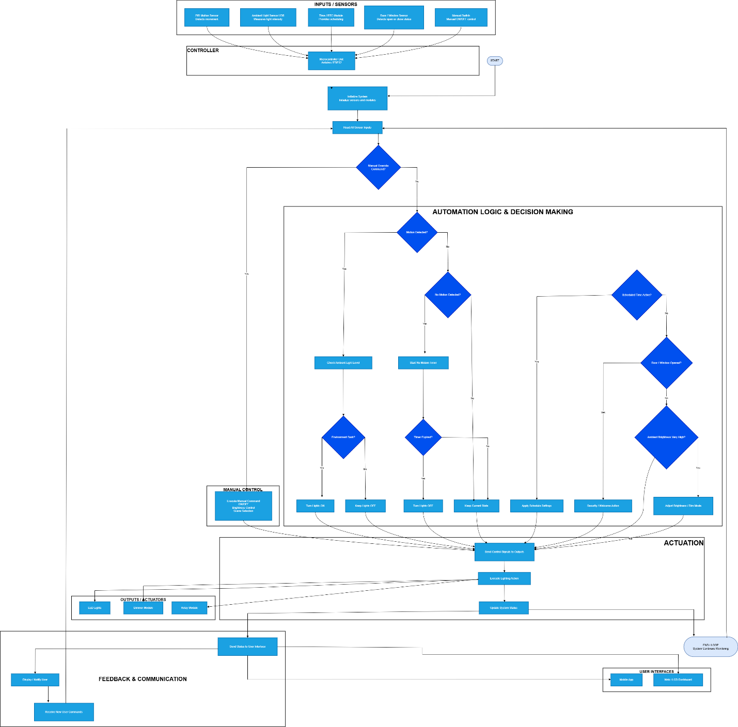

Figure 1.1. Flow Chart Diagram of a Smart Home Lighting System
1.2 System Components
The system is made up of several important components that work together to achieve automation. A PIR motion sensor is used to detect human movement within the environment, while a Light Dependent Resistor (LDR) sensor is used to measure surrounding light intensity. A Real-Time Clock (RTC) module is included for time scheduling operations, and a door/window sensor is used for security and automation purposes.
The main controller of the system is a microcontroller such as Arduino or ESP32. The controller processes information received from sensors and sends commands to output devices. Output components include LED lights, a dimmer module for brightness adjustment, and a relay module for switching operations. User interaction is supported through a mobile application and dashboard interface.
1.3 System Operation
The system operates by continuously monitoring environmental conditions through connected sensors. During initialization, all sensors, modules, and communication systems are activated by the microcontroller.
Sensor data is then collected and analyzed. If manual control commands are received through the user interface, the requested lighting operation is executed directly. However, when the system is operating in automatic mode, intelligent decision-making processes are followed.
When motion is detected in a dark environment, the controller automatically switches the lights ON. If no movement is detected after a specified delay period, the lights are turned OFF automatically to reduce unnecessary energy consumption.
Additional functions such as scheduled lighting control, brightness adjustment, and security-triggered lighting actions are also included in the system. The system continuously updates operational status and communicates feedback to the user interface for monitoring purposes.
1.4 Advantages of the System
Several advantages are provided by the smart home lighting system. Energy consumption is reduced through automatic switching and brightness control. User convenience is improved because lighting operations can be performed automatically without manual intervention. Home security is also enhanced through motion detection and automated lighting responses. In addition, the system provides flexibility through remote monitoring and scheduling features.
1.5 Conclusion
The smart home lighting system demonstrates how automation and intelligent control technologies can be applied in modern homes to improve efficiency, convenience, and safety. Through the integration of sensors, microcontrollers, and automated decision-making processes, lighting operations are able to be controlled effectively with minimal human involvement. As smart automation technologies continue to advance, similar intelligent systems are expected to become increasingly important in future residential and industrial applications.

